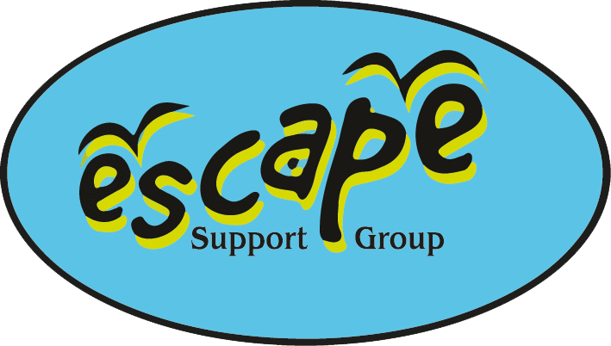
Policy Title: Privacy Policy
Policy Number EIGHT
Policy Approved by Escape Committee……………………………Date…..…..
Review:……………………….
Controlled Copy
Privacy Policy
Who are we?
We’re Escape Support Group, a registered charity (no. 1081446), who provide support to families living in Somerset who are raising children who have disabilities or individual needs. The registered address is Escape Support Group, Unit H, Creech Business Park, Mill Lane, Creech St Michael, Taunton, Somerset, TA3 5PX .
How do we collect information from you?
We obtain information about you when you complete our membership form. Information is also obtained when accessing the website.
What type of information is collected from you?
The personal information we collect includes your name, address, email address, telephone and mobile numbers, and information regarding your child, their date of birth, and their individual needs, as well as any siblings and close family members who might access Escape’s trips.
How is your information used?
We may use your information to:
Contact you regarding up and coming events organised by Escape – either via e-newsletter or by post via a hard copy.
Contact you individually regarding the trips you have booked.
Inform you, via email, of products/services/activities that might be relevant to you and your family.
Take photos on our trips and use them when applying for grants. There is an opt out option on the membership form.
Members of Escape can choose to “Like” our facebook page, where further information is available regarding what’s on and when. Members have the choice to unfollow this page at any time if they do not want to be notified of updates from Escape Support Group.
We review our retention periods for personal information on a regular basis. We are legally required to hold some types of information to fulfil our statutory obligations (for example the collection of Gift Aid). We will hold your personal information on our systems for as long as you wish to remain a member. We annually renew membership in April. Anyone not responding to renewal reminders will automatically be deleted at the beginning at the end of May each year. Anyone wishing to renew after this time will be required to complete a new membership form.
Who has access to your information?
We will not share your information with anyone, unless we have your prior consent (e.g. contacting other support services on your behalf).
We will not share, sell or rent your information to third parties for marketing purposes.
Online Donations
When you are using our secure online donation service via our website, your donation is processed by a third party payment processor, who specialises in the secure online capture and processing of credit/debit card transactions. If you have any questions regarding secure transactions, please contact us.
Your choices
You have a choice about whether or not you wish to receive information from us. If you do not want to receive further contact from Escape Support Group prior to the following April please email help@escapesupportgroup.com, and ask for your information to be removed from the database.
How you can access and update your information
The accuracy of your information is important to us. We’re working on ways to make it easier for you to review and correct the information that we hold about you. We currently ask you to annually check the details we hold at the time of membership renewal. In the meantime, if you change email address, or any of the other information we hold is inaccurate or out of date, please email us at: help@escapesupportgroup.com or post it to Escape Support Group, Unit H, Creech Business Park, Mill Lane, Creech st Michael, Taunton, Somerset, TA3 5PX or telephone 01823 442160. You have the right to ask for a copy of the information Escape Support Group hold about you.
Security precautions in place to protect the loss, misuse or alteration of your information
When you give us personal information, we take steps to ensure that it’s treated securely. Any sensitive information (such as details regarding your child) is held on a database which is accessed via Google Drive. Each PC or laptop that has access to this information is password protected. Added to this the Google Drive account is password protected. The office in which these PCs sit is protected by an alarm which, if triggered, will result in the police being informed.
Non-sensitive details (your email address etc.) are transmitted normally over the Internet, and this can never be guaranteed to be 100% secure. As a result, while we strive to protect your personal information, we cannot guarantee the security of any information you transmit to us, and you do so at your own risk. Once we receive your information, we make our best effort to ensure its security on our systems.

Links to other websites
Our website may contain links to other websites run by other organisations. This privacy policy applies only to our website‚ so we encourage you to read the privacy statements on the other websites you visit. We cannot be responsible for the privacy policies and practices of other sites even if you access them using links from our website.
In addition, if you linked to our website from a third party site, we cannot be responsible for the privacy policies and practices of the owners and operators of that third party site and recommend that you check the policy of that third party site.
16 or Under
We are concerned to protect the privacy of children aged 16 or under. If you are aged 16 or under‚ please get your parent/guardian's permission beforehand whenever you provide us with personal information.
Review of this Policy
We keep this Policy under regular review. This Policy was last updated in May 2019.

Signed ;……………………………….. Position…………………………………..
Date ……………………………………

