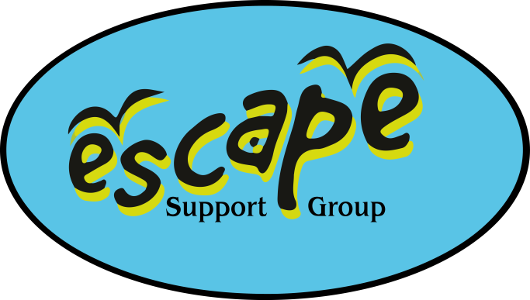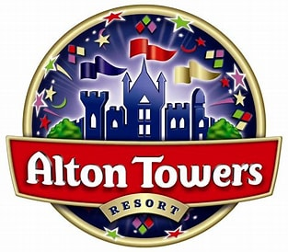

Monday 27th – Thursday 30th October

If you are unable to attend on the day please contact Kirsty, Debbie or Ang via the mobile phone on 07982712608.

Monday 27th October
Warwick Castle: Sarah will be arriving at opening at 10am, ahead of the coach and will be at the entrance to distribute your tickets, these will be excluding carer tickets. At the entrance, carer tickets will be allocated to each individual family, so you will need to show your evidence for the free carer ticket before entering the venue. If you do not have that with you, you will be charged the day entry fee. Check the accessibility guide for the accepted evidence.
Parking is chargeable for all cars.
Is there a charge for Car Parking? – Official Warwick Castle website: Best Price Guaranteed for Britain's Ultimate Castle.
Do you offer Disabled Parking? – Official Warwick Castle website: Best Price Guaranteed for Britain's Ultimate Castle.
Opening times 10am – 5pm.
Check out the accessibility guide - Accessibility | Warwick Castle
The coaches plan to arrive at Alton Towers around 5pm, again Sarah will be arriving earlier to assist with check in (around 3.30pm), and she will be in reception until 5.30pm. We ask that only one member of your group collects the room cards, and your theme park tickets will be enclosed with this. Any room requests have been sent to the hotel, but rooming allocation is in the hands of the resort. Any issues with your room, please inform Reception.
Check in is from 3pm, if you arrive before Sarah, who will arrive around 3.30pm, or after 5.30pm, please go to reception, give your name and say you are part of a group booking with Escape.
Parking is available at Splash Landings Hotel
(Ride Access passes will be distributed at the swimming session in the evening).
Private Hire of Splash Landings pool in the hotel Monday evening 7pm-9pm.
Escape staff will have a list of attendees, this is an exclusive session for Escape families.
The café in the waterpark will be open in the evening for you to purchase food, please note your own food is not permitted in the waterpark
Accessibility - Special Facilities | Alton Towers Resort
Tuesday 28th October
You should already have booked your breakfast slot online, and the day is free to do as you please – Theme park tickets were in with your room cards.
Wednesday 29th October
You should already have booked your breakfast slot online, and the day is free to do as you please – Theme park tickets were in with your room cards
Thursday 30th October
You should already have booked your breakfast slot online. Tickets for this day are not included in the package.
RIDE ACCESS PASS INFORMATION
The Ride Access Pass timecard and wristband will be given to the eligible person** (max of 4 people per group in total including the individual).
Step 1:
Your wristband and timecards will be distributed at the swim session on the Monday night, negating the need to queue at guest services on the first day, this will come in the form of wrist bands and timecards, both to be used together at each individual rides.
Step 2:
Once you have your Ride Access Pass wrist band and timecard, you will be able to go to your first ride, all rides have a designated Ride Access Pass Queue and are all sign posted. Simply go through this queue line and a member of our team will greet you, here they will take your time sheet and put the queue length from when you got there (If you arrive at Smiler at 12:00 and they have a 30 minute queue they will put 12:30) As this is your first ride, you will be allowed to access the ride straight away and the time stamp will be for your next ride.
Step 3:
Once your wait time is up, head to your next ride and then repeat step 2
The person that will be allocated the pass is the young person registered on your membership with Escape with the disability/additional need.

