 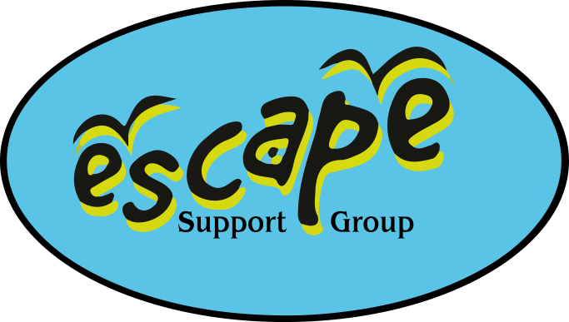

Thursday 28th August 2025

Splashdown Quaywest, Paignton

If you are unable to attend on the day please contact Debbie or Kirsty via the mobile phone on **07982712608.**

We have booked a 3 hour swim session from 2pm til 5pm, please arrive ay least 10 minutes before.

On arrival please go to reception, where they will be holding a list of Escape members. Just let them have your surname and the number of people in your group, and they will sign you in.

Have a great time!