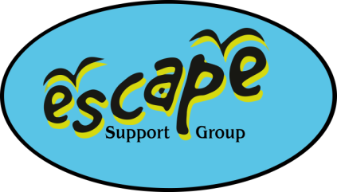

Thursday 28th August 2025

Splashdown Quaywest, Paignton

**Anyone using digital devices on the coach where audio is involved MUST wear headphones whilst using them, to ensure the comfort of all coach users.**

If you are unable to attend on the day please contact Kirsty or Debbie via the mobile phone on **07982712608.**

**PLEASE ARRIVE AT LEAST 10 MINUTES PRIOR TO DEPARTURE TO ENSURE WE LEAVE ON TIME.**

**Leaving BRIDGWATER at approx. 8.30am – Bridgwater Bus Station**

Parking available in car park behind – press yellow button for 70p all day parking. REMEMBER TO LEAVE THE NOTE IN YOUR WINDSCREEN STATING YOU ARE WITH ESCAPE, ON A BERRY’S COACH, FROM 7.30AM – 6.30PM.

**Leaving TAUNTON at 9.00am – Creechbarrow Road, outside Asda Taunton**

Parking is free, please park at the bottom of the Asda car park by the petrol station, and make your way to the bus stop on Creechbarrow Road just outside Asda.

**Please ensure you have given your car registration number in advance so staff can input the details in store on your behalf.**

We will arrive around 10.30am where you will be free to explore the local area for a few hours, enjoy a picnic or find somewhere for a spot of lunch. Splashdown Quaywest is in a unique location, situated on stunning beach and close to many historical landmarks and outstanding areas of natural beauty. We have booked a 3 hour swim session from 2pm til 5pm to depart for the journey home at 5.30pm.

**Please meet Debbie & Kirsty back at the coach drop off for a PROMPT 5.30pm departure, arriving back Taunton 7.00pm, Bridgwater approx. 7.30pm ….traffic dependent.**

**COACH ETIQUETTE…**

Please sit your family as a group together.

Please ensure all seat belts are done up for the duration of the journey.

Children should at no time be out of their seats.

Rubbish should be placed in the bags provided, or taken home with you. Please leave the coach as we find it.

Thank you.