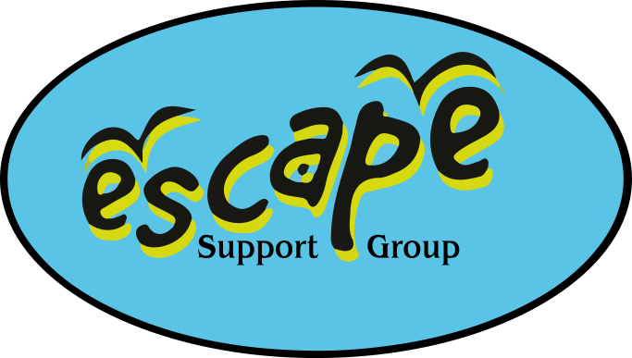 

Tuesday 12th August 2025

**Lodmoor Park & Aquarium, DT4 7SX**

If you are unable to attend on the day please contact Debbie or Kirsty via the mobile phone on **07982712608.**

There is a splash zone and pool, so please bring swimwear and a towel.

**We have pre-booked a slot at the aquarium from 10.45am please quote order number 594703667 on arrival**

Debbie/Kirsty aim to be there for 10.30am traffic dependant.

Have a great time!